HOW TO RENEW SYNOLOGY CERTIFICATE

1. Control panel

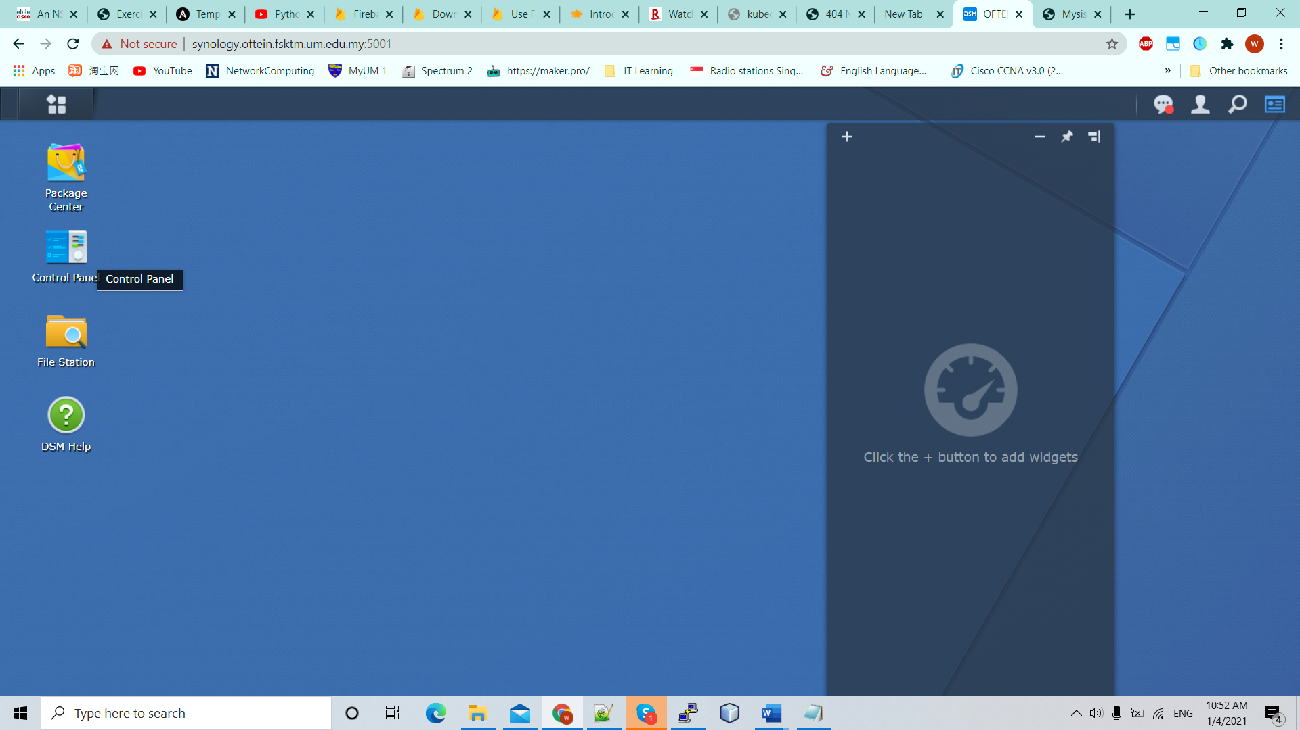

2)Security

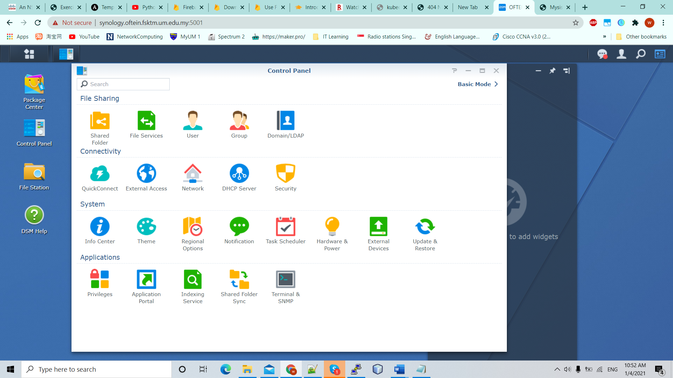

3)Certificate

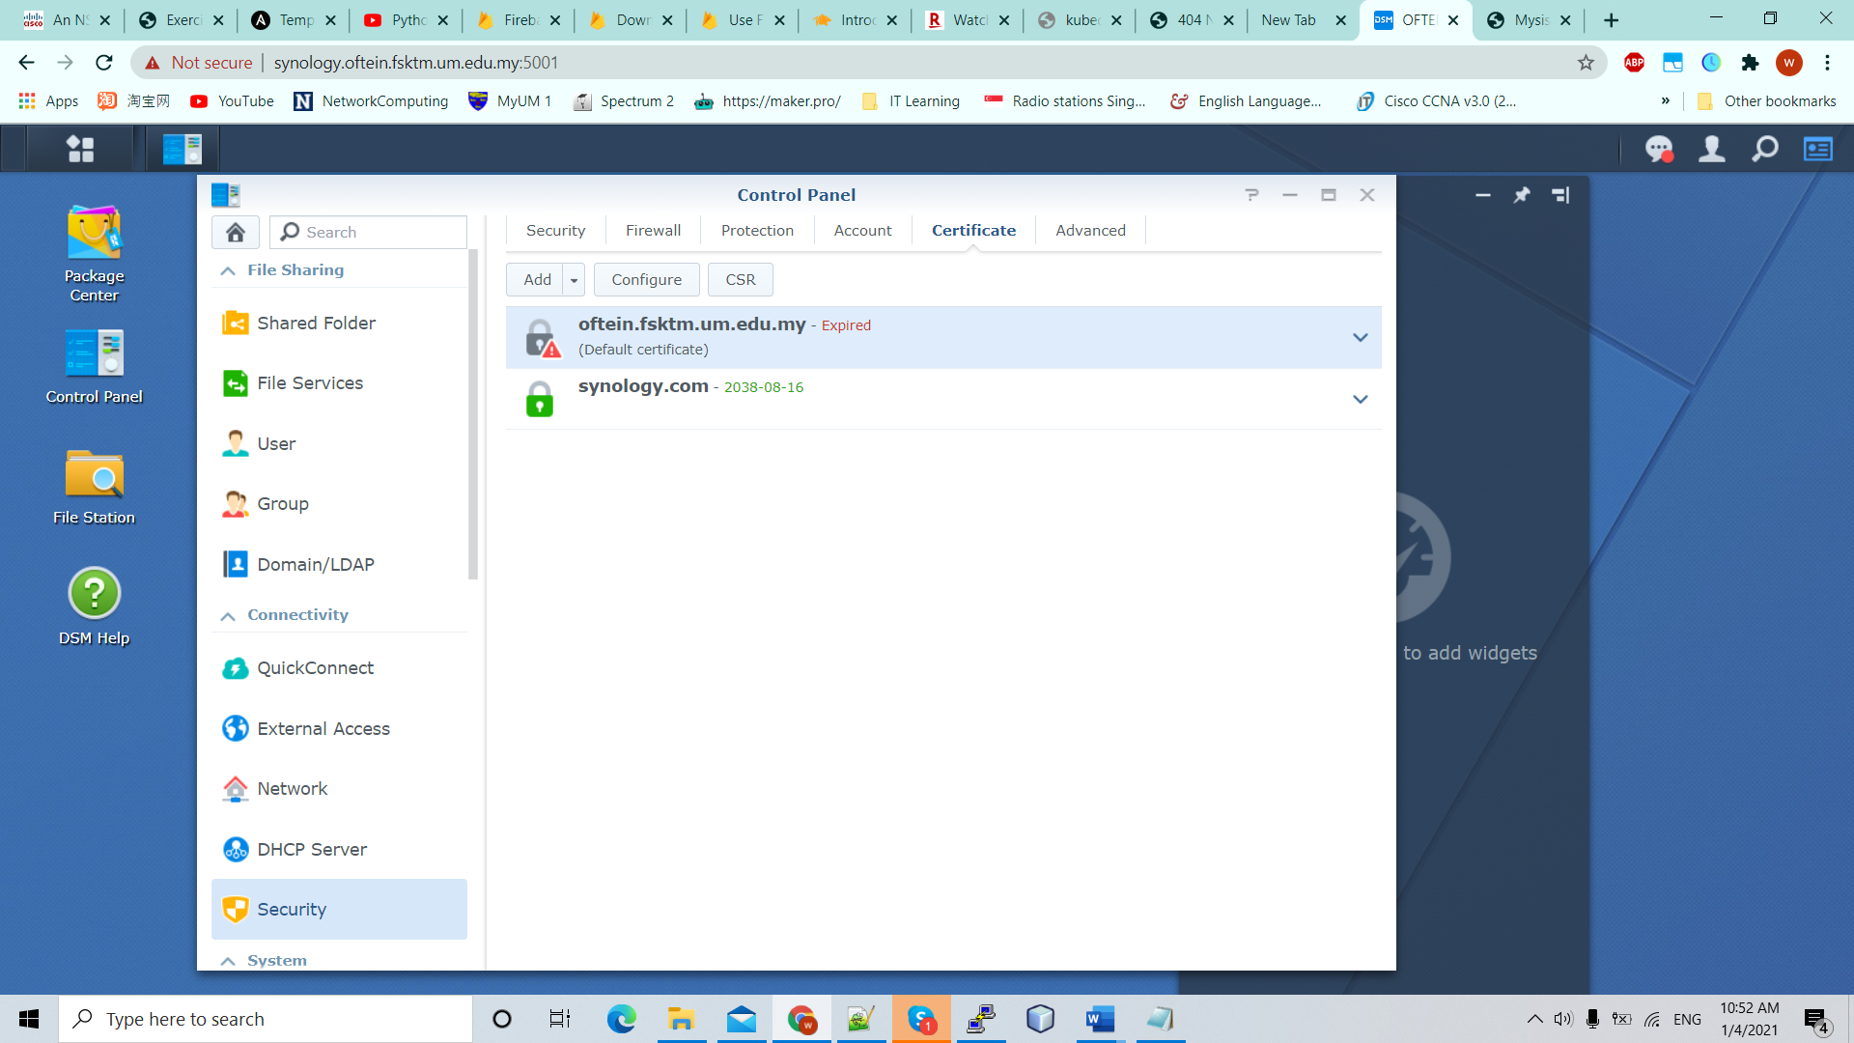

4) Add

